(Approx. 569 words)

Smartphone Map Apps vs. Dedicated GPS Devices
Author: Dorothy Fitch, Green Bytes Editor, GVR Computer Club, AZ
October 2019 issue, Greenbytes
www.ccgvaz.org
Newsletter (at) ccgvaz.org

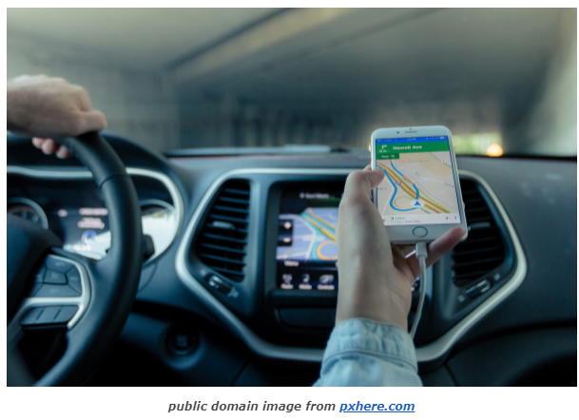
I recently heard an interesting report on a local television station about the pros and cons of using your Smartphone vs. a GPS device to find your way when you travel. I am certainly not an expert on this topic but wanted to share a few things I discovered as well as some links so that you can learn more, too.
I hadn't really thought about it, but perhaps the biggest difference between the two is that Smartphone map apps use cell tower signals to provide your location and generate maps. GPS devices, such as Garmin or TomTom, use satellites for positioning.
What this means is that if you are in a remote area that doesn't have cell coverage, maps on your phone will likely not work.
Other interesting considerations:
GPS devices are more accurate—to within 15 feet your location— because they are using satellite technology.
Smartphone locations are accurate to about 164 feet. Your location is determined by triangulating signals from several cell towers.
A Smartphone app uses your phone's battery (though you may be able to charge it in your car via USB). Beware, however, that on a recent trip, my Android phone was plugged in. During the half-hour trip, the phone's battery level dropped by 4% because the power used by the app was greater than the rate of charging.
A GPS device will plug into your car's cigarette lighter or USB port.
Using a GPS device will leave your Smartphone available for other purposes (though not when you are driving, of course!).
A Smartphone app will use up mobile data, which may be of concern if your phone service doesn't include an unlimited data plan.
GPS devices often come with a way to mount them to your dashboard, which makes it easier to check your route.
The Google Maps Smartphone app gives you up-to-the-minute accident reports. It even prompts you to respond as to whether the accident someone reported earlier is still there. It provides an estimated time delay, as well as alternate routes.
Some GPS devices offer traffic alerts as well.
Using the Google Maps Smartphone app, I was surprised one time when I entered the address of my destination, which was a store. I got immediate feedback that the store had already closed for the day. Very useful information to know (and saved me a stop).
Many GPS devices include lifetime map updates. This can be handy, as new housing developments are constructed. You can also download (or purchase) maps for foreign countries. You can likely use your Smartphone app abroad, but I haven't tried that.
Some GPS devices can store your trip data, which you can then download to a map, where it displays your route. This is particularly interesting if you are hiking or on a boat.
If you are car-shopping, you may be offered a package that includes a built-in GPS system. However, that option is likely to cost much more than the price of a hand-held separate device.
Articles on the subject:
- Do I need a dedicated GPS device if I have a smartphone?
- Can you trust your phone's GPS driving directions?
- Smartphone vs. Dedicated Car GPS (PND)
- The 7 Best Traffic Apps of 2019
- 44 Google Maps Tricks You Need to Try

